Arizona State University Department of Engineering
Photovoltaic Power Output Research Proposal
Submitted by: John Smith
Submitted on: July 9, 2013

Abstract:
Future energy and power needs in the world are threatened by the possibility of a shortage of fossil fuels. Recent research has shown that the current reserves of oil and natural gas are predicted to diminish within the next 40 and 70 years, respectively [1]. In addition, the production rate of carbon emissions is rising, increasing at more than 3% per year [2]. Many solutions to the fossil fuels and carbon emissions issues have been proposed and are even under way. It is proposed that further research is necessary in the power efficiency and carbon emissions production areas of photovoltaic power generation technology as part of these efforts.
Introduction:
Research into the question of the longevity of continued rising use of fossil fuels has produced numerous proposed values. Recently, Shafiee and Topal have stated that oil is calculated to run out in 40 years. Given the worldwide dependence on oil and oil byproducts, this figure gives cause for great concern for the future of our children [1]. The following proposal outlines the intent to research photovoltaic power in an effort to answer these issues.
Problem Statement:
Photovoltaic (PV) solar modules produce a vast and dynamic range of power efficiencies at varying costs. Given a vast array of material combinations used for p and n junctions, including materials used in substrates and veneers, a comparison of power efficiencies and production of pollutants in manufacturing of PV panels is necessary.
Ongoing research and development of PV panels has shown increases in the power efficiency of emerging technologies. As additional materials are discovered to produce greater outputs, efficiencies are reaching up to 44% [3].
In the meantime, chemical substrates, such as Cadmium Telluride, Gallium Arsenide, Silicone and more, are being used in the production of the most efficient PV panels. These chemicals are highly toxic. Were greater amounts of these materials to be deposited into the ground and absorbed by human or animal consumption channels, the effects could be catastrophic.
Purpose of Study:
The purpose of this study is to research a comparison of the pollutants used and produced in the production of PV panels in comparison to the power efficiencies of various modules.
Significance of Research:
Data produced from this study will be used to show this comparison and provide insight into the issue of furthering responsible environmental practices in manufacturing. In addition, it is hoped that this project will be the beginning of an ongoing body of research into the issue of monitoring manufacturing pollution.
Methodology:
Data collection methods will be employed on several PV modules, including analyses of manufacturing methods, pollutant handling methods, PV panel disposal policies, and power efficiencies of various technologies.
Research Design:
The processes and methods of PV panel manufacturing and material and chemical handling will be researched through literature reviews, observation, and interviews with manufacturers themselves. In addition, federal and state manufacturing policy will be reviewed.
Literature research will consist of reviewing engineering journal articles on the subject matter through a search of the online library. In addition, the “Handbook of Photovoltaic Science and Engineering” will be used as a primary reference for much of the initial information.
Following the literature review, manufacturing companies within the United States will be contacted for interviews. This process will be used to determine a viable subject pool for actual manufacturing plant visitation. Interviews will be focused on the manufacturing processes with intent to remove any biases about handling of materials and chemicals.
Finally, from the plant pool described above, as many manufacturing plants as can be visited within the budget of the project will be scheduled for visitation. Observations of the methods and practices of each manufacturing plant will be conducted with the intent of recording these processes first hand.
PV panel disposal policies will be researched through a literature review, as stated above. The current state of affairs in panel disposal will also be researched.
Finally, samples of as many PV panels as can be obtained will be analyzed to determine their power output and efficiency. Efficiency will be calculated as the ratio of total available irradiation from the sun at the surface of the panel compared with the total power output of the panel, as seen in Equation 1, below.
For literature reviews, interviews and observations, instrumentation will not be required. A camera will be used to record manufacturing practices within plants.
In order to simulate controlled sunlight conditions, two 500 watt halogen work lamps will be required. In order to create controlled research conditions, the refrigerator in the engineering laboratory will be used to simulate lower temperatures.
For the analyses of PV panel efficiencies, the power output will be recorded using a Fluke 73 III multimeter, as seen in Figure 1, below. This will be used to record the voltage and amperage of the PV panel output. The voltage and current recorded will be multiplied to determine the power output, as seen in Equation 2.
(1)
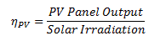
Instrumentation:
For literature reviews, interviews and observations, instrumentation will not be required. A camera will be used to record manufacturing practices within plants.
In order to simulate controlled sunlight conditions, two 500 watt halogen work lamps will be required. In order to create controlled research conditions, the refrigerator in the engineering laboratory will be used to simulate lower temperatures.
For the analyses of PV panel efficiencies, the power output will be recorded using a Fluke 73 III multimeter, as seen in Figure 1, below. This will be used to record the voltage and amperage of the PV panel output. The voltage and current recorded will be multiplied to determine the power output, as seen in Equation 2.
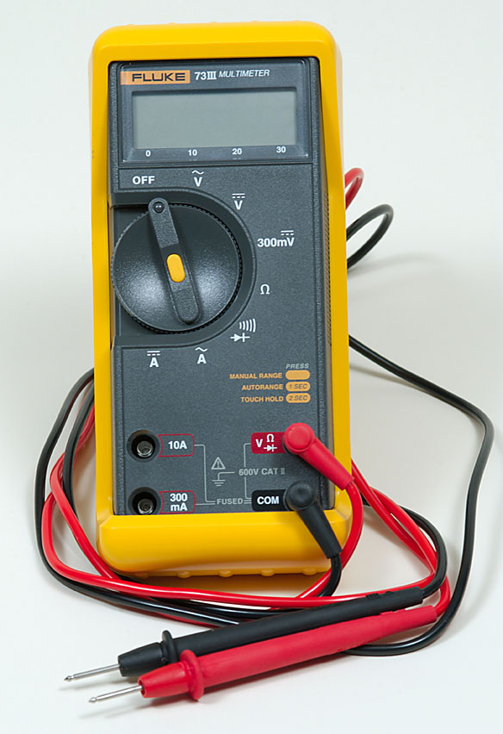
Figure 1 Fluke 73 III Multimeter
Data Collection and Analysis Procedures:
Pollution output data will be collected from literature reviews and any additional documentation discovered in the research process, such as records from manufacturers. The final objective of the pollution data collection will be to produce a data table showing the amount of pollution created for each individual panel, by type, in micrograms per cubic meter of air.
The power efficiency of each PV panel will be measured using the Fluke 73 III micrometer described above. Voltage and current outputs of each panel will be recorded at the output leads. Data will be recorded at various temperatures, to include 0oC, 5oC, 10oC, 20oC, 25oC and 35oC. These temperatures will be controlled using the walkin refrigeration unit available in the engineering building.
Solar irradiation will be simulated using two 500 watt halogen work lights. The lights will be focused on the solar panels such that 1000 watts per square meter of light will be concentrated on their surface.
The primary data collected from this project will be the projected pollutant production in micrograms per cubic meter and output efficiencies of PV panels at various temperatures. For the analysis the pollution output of each panel will be compared to the power efficiency such that a graph will be produced to show the comparison.
Relevant Institutional Resources:
A number of useful resources are made available by Arizona State University. As stated above, the online library at ASU is sufficient for all literature research needs. In addition, the walkin refrigeration unit will be sufficient to provide controlled temperature conditions for the PV panel analyses.
Travel accommodations for this proposal will be factored into the budget. However, it is possible for some interviews to be conducted at solar power conferences, which will be attended through the engineering department. Travel scholarships are often provided through the university and will be applied for in the process of research.
Budget:
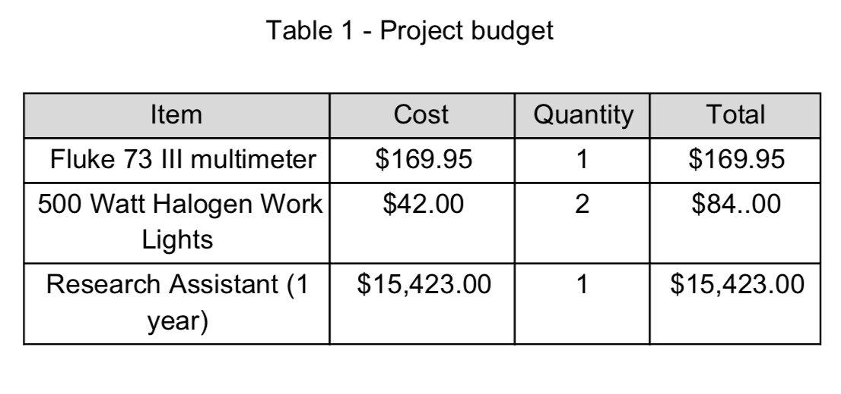
The following table shows the items and budgeted amounts for each.

References
. [1] S. Shafiee and E. Topal, "When will fossil fuel reserves diminish?," vol. 37, 2009.
. [2] Daily Kos Group, "CO2 Emissions Rate Grew 3.1%/yr for 20002012: Catastrophic Exponential Growth," 2 December 2012. [Online]. Available: http://www.dailykos.com/story/2012/12/02/1166704/CO2EmissionsExponentialGrow th31yrfor20002012ACatastrophicRate#. [Accessed 9 July 2013].
. [3] D. Tom, "Sharp develops world's most efficient solar panel," 14 June 2013. [Online]. Available:
http://www.techspot.com/news/52907sharpdevelopsworldsmostefficientsolarpane l.html. [Accessed 9 July 2013].

